Mid Atlantic Division-1146 N Irving Allentown Pa. 18109
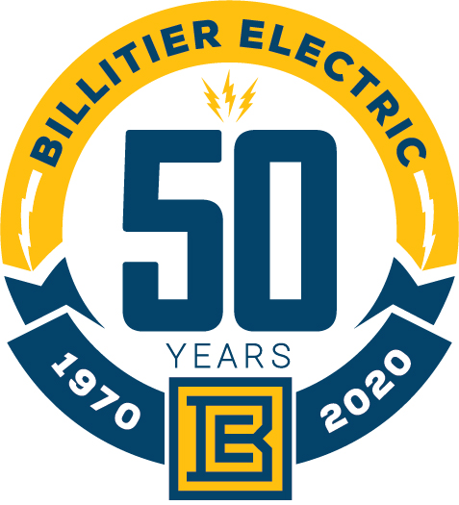
Commercial & Industrial Wiring – Sound Data & Communications
A Mid-Atlantic Contractor Servicing New York, Pennsylvania, and New Jersey
760 Brooks Ave, Rochester, NY 14619 • (585) 224-1111 • Fax: (585) 224-1110 • www.billitierelectric.com

Request for quote from certified DBE for listed materials for Monroe County Transportation Authority, Swiftwater Bus Wash.
Requested by August 10,2020
Please see attached Lighting Fixture Schedule and quantities.
I have also attached electrical specifications and full set of plans

